**Project Design Phase**

**Solution Architecture**

| Date | 15 April 2025 |
| --- | --- |
| Team ID | SWTID1742572631 |
| Project Name | Movie Ticket Booking System |
| Maximum Marks | 4 Marks |

**Solution Architecture:**

Popcorn Tickets is a cloud-native, web-based movie ticket booking platform designed to offer users a fast, seamless, and localized experience across both multiplexes and single-screen theaters. The architecture is modular, secure, scalable, and optimized for performance.

This architecture aims to:

* Provide the best technological solution to the fragmented and inconsistent movie ticketing ecosystem.
* Clearly define the structural and functional components of the software system.
* Establish development phases and technology choices for scalability, security, and maintainability.
* Offer detailed architectural blueprints that will guide development and implementation across all touchpoints.

**Example Solution Architecture Diagram:**

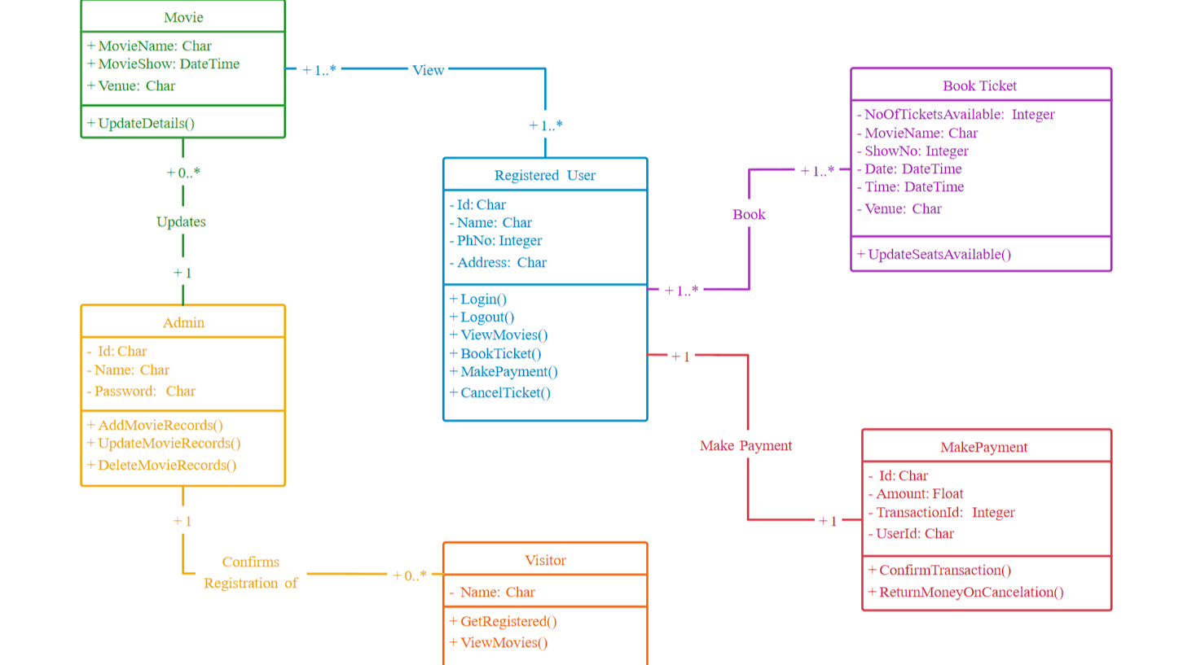

**Reference:**

https://creately.com/diagram/example/hz1eoim38/online-movie-ticket-booking-system